Autism Spectrum Disorder (ASD)
Autism Spectrum Disorder is a neurodevelopmental disorder characterized by persistent deficits in social communication and restricted, repetitive behaviors. Symptoms begin in early childhood and vary widely in severity.
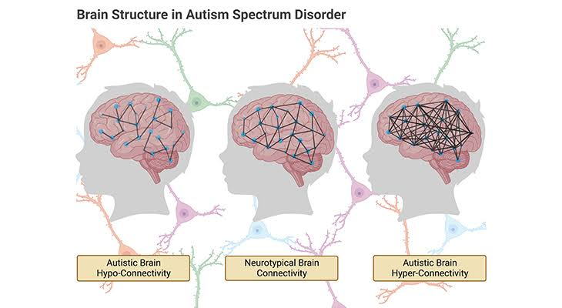

Brain Regions
- Prefrontal cortex
- Amygdala
- Cerebellum
- Temporal cortex
- Corpus callosum

Pathophysiology
- Abnormal synaptic development
- Altered neuronal connectivity
- Excitation–inhibition imbalance
- Neuroinflammation
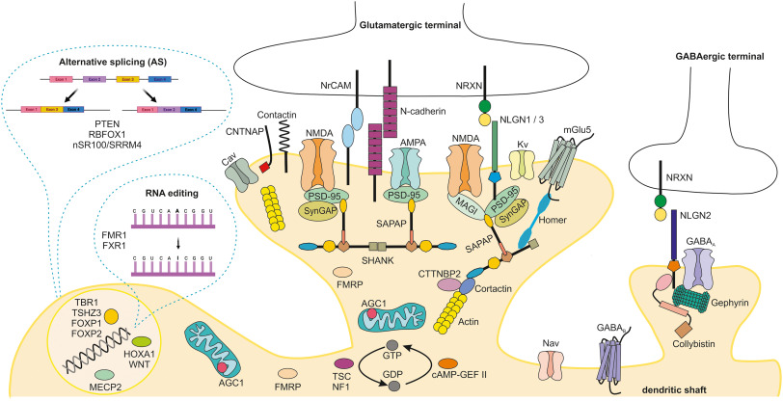

Genetics
- SHANK3
- CHD8
- SCN2A
- FMR1
- MECP2

Symptoms
- Social communication deficits
- Limited eye contact
- Repetitive behaviors
- Sensory hypersensitivity
- Delayed language
- Restricted interests
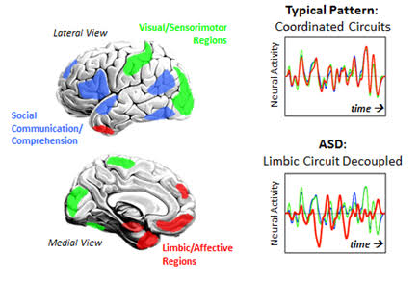

Diagnosis
- DSM-5 criteria
- ADOS-2
- ADI-R
- Developmental assessment

Treatment
- Applied Behavior Analysis (ABA)
- Speech therapy
- Occupational therapy
- Social skills training
- Educational support

